**Name: JOMOL R.K**

**Roll No:09**

**Batch:S2 MCA**

**Date:21-03-2022**

**NETWORKING & SYSTEM ADMINISTRATION LAB**

**Experiment No.: 1**

**Aim**

Install the latest version of Ubuntu on an Oracle VM VirtualBox.

**Procedure**

**Step 1: start to install oracle VM VirtualBox 6.1.32 in our computer**

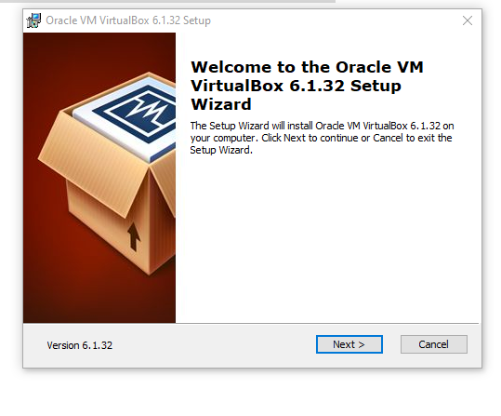

**Step 2: To custom setup for change the way features will be installed**

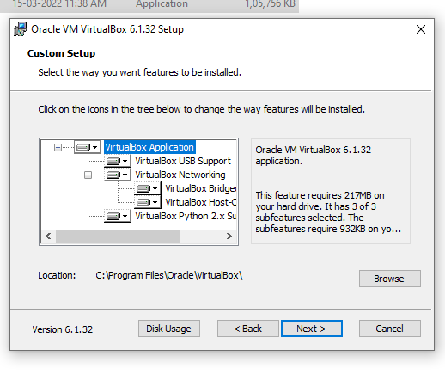

**Step 3: Choosing the options for the features installed**

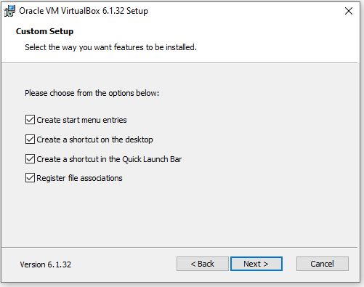

**Step 4: proceed for the installation from a networking interfaces**

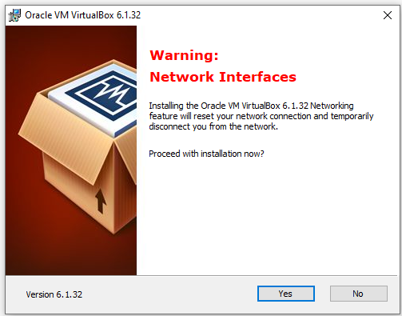

**Step 5: click install which ready to installation**

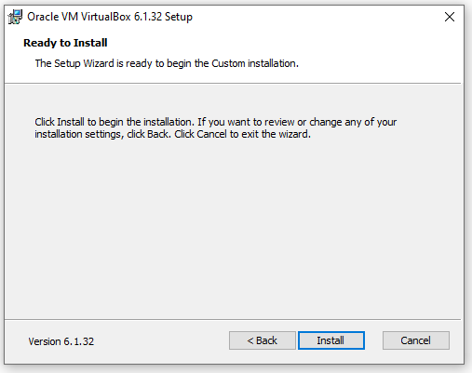

**Step 6: Install the device software**

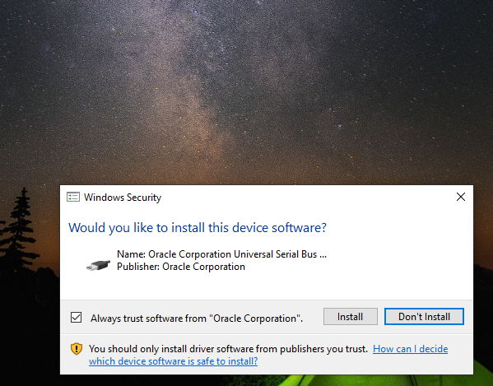

**Step 7: Finish the installation**

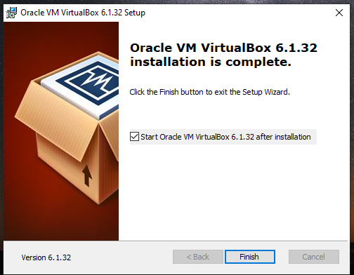

**Step 8: Open the VirtualBox**

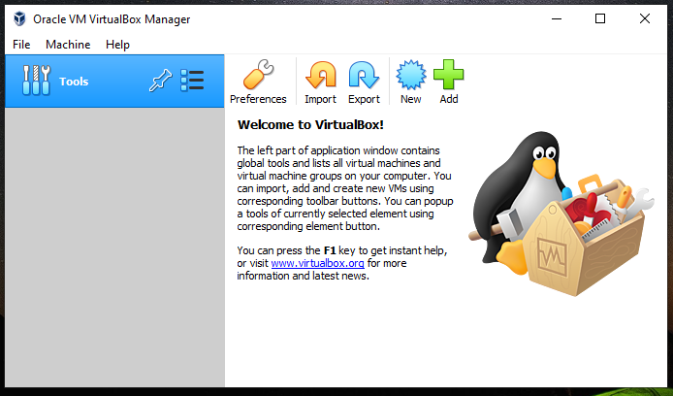

**Step 9: Select the “start”**

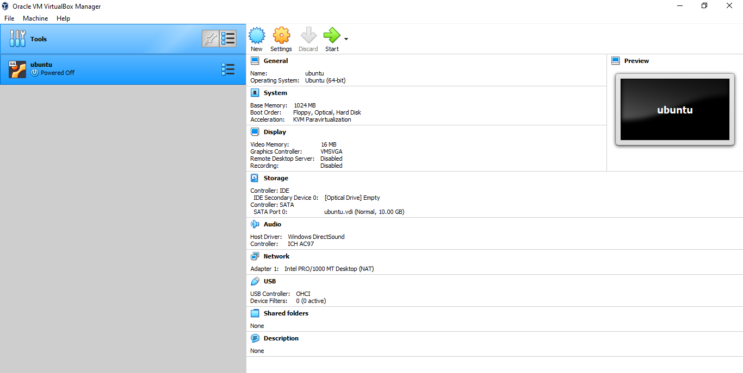

**Step 10: Create virtual hard disk**

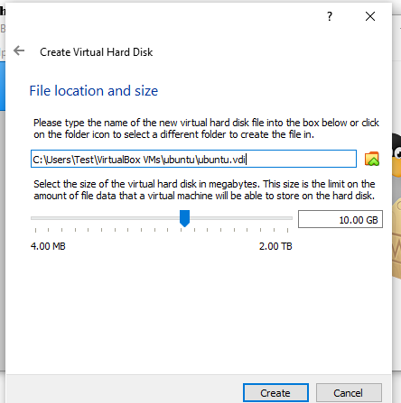

**Step 11: Select the settings and set name as ubuntu**

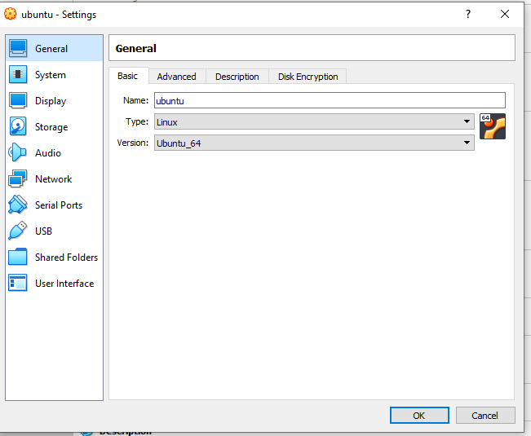

**Step 12:Set storage on physical hard disk as dynamically allocated**

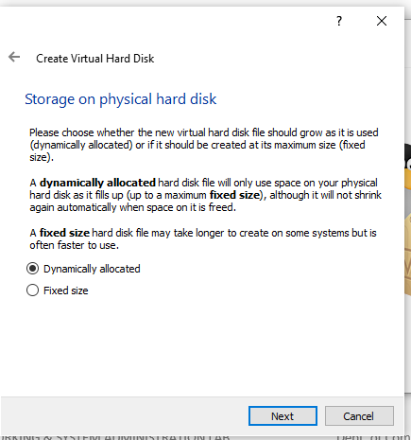

**Step 13: Set hard disk file type as VDI and click “next”**

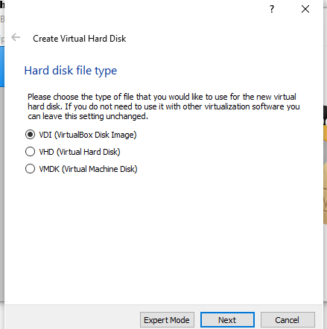

**Step 14: Create hard disk as new machine set and click “create”**

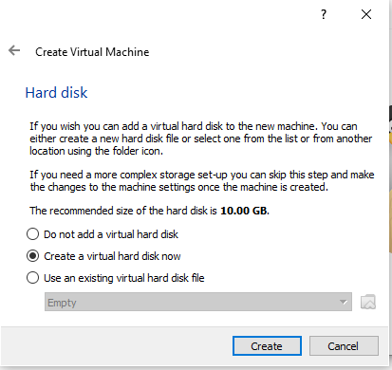

**Step 15: Click “ok” in settings-storage**

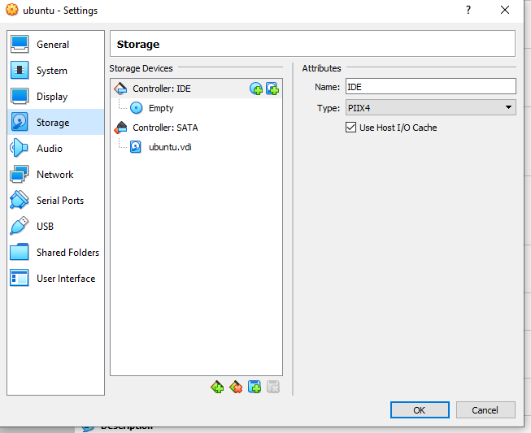

**Step 16: Click to empty in storage and click “ok”**

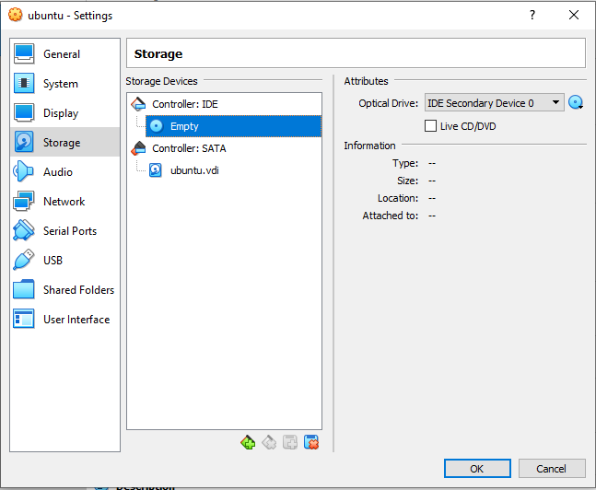

**Step 17: choose the optical drive**

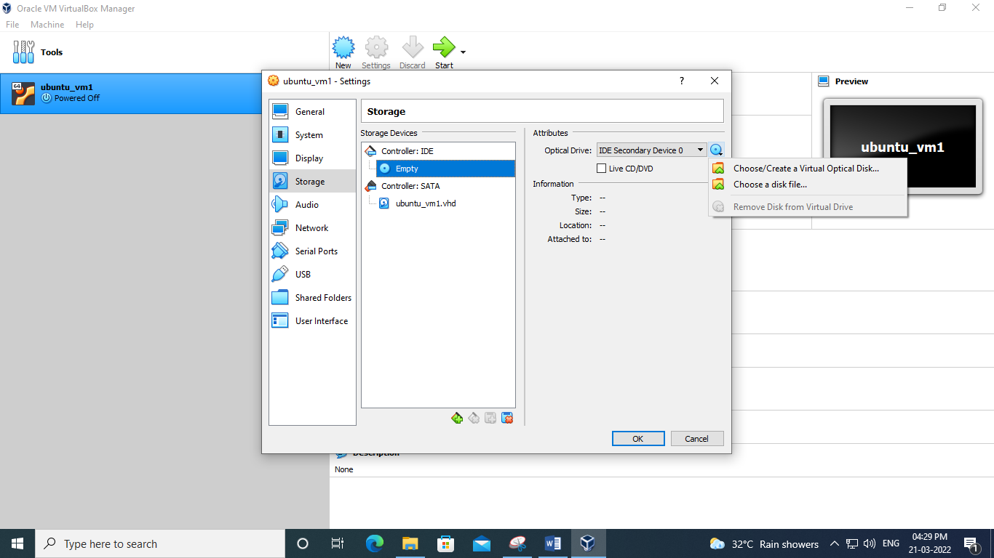

**Step 19: select the controller IDE and click “ok”**

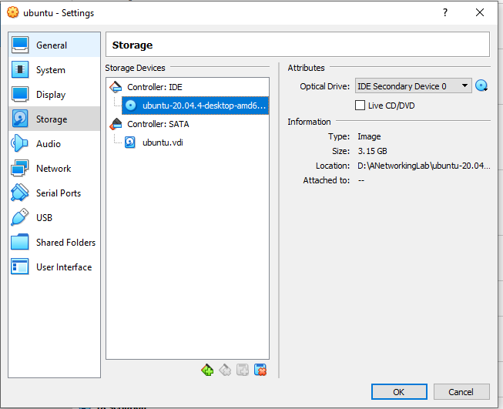

**Step 20: start to installing**

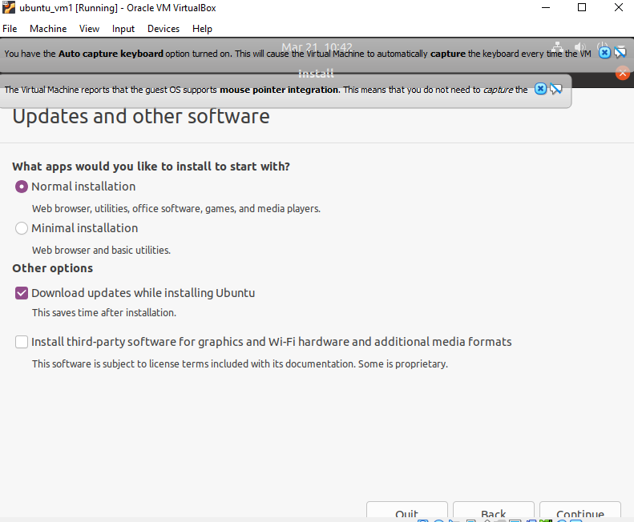

**Step 21: select the installation type**

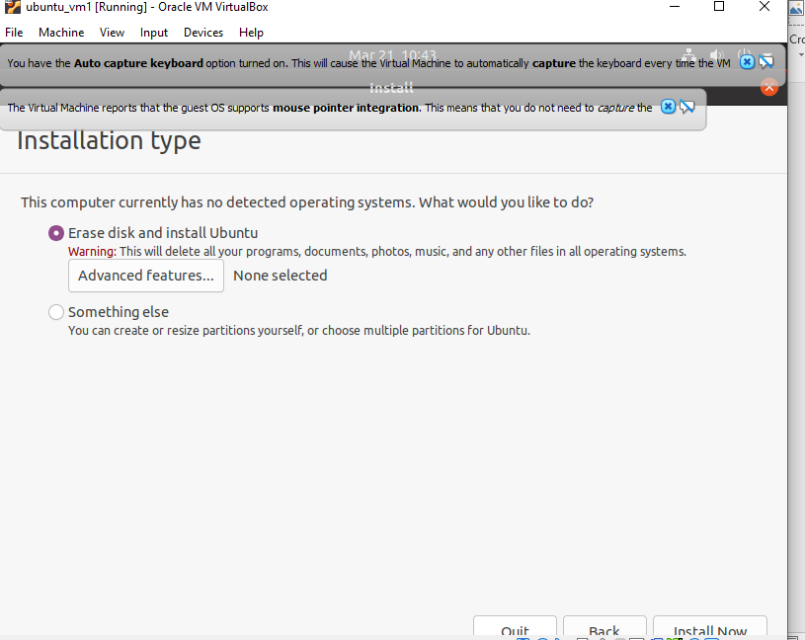

**Step 22: installed it**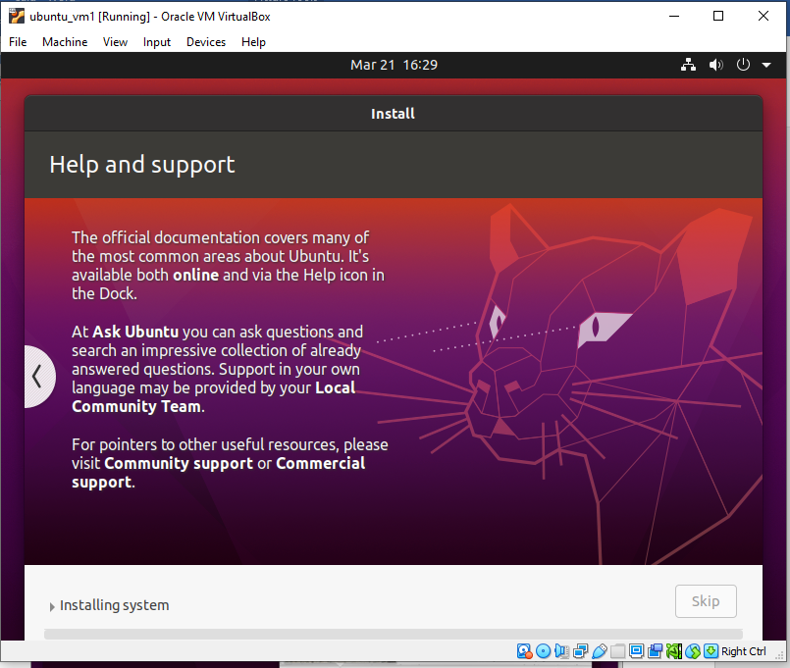

**Step 23: Ubundu window will be in progress**

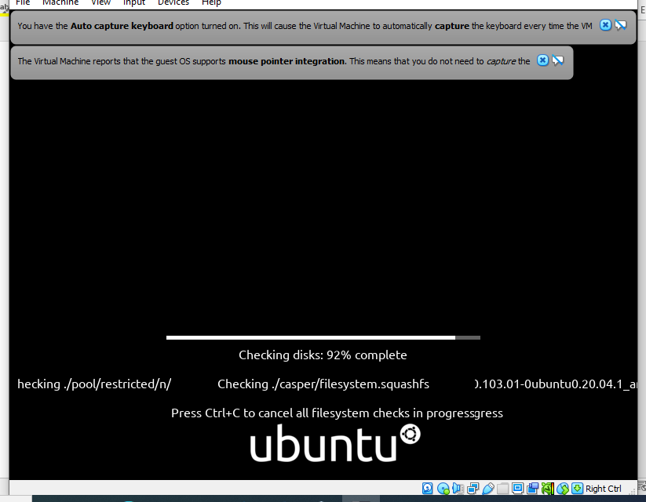

**Step 24: Restart the system for changes applied and click to view then switch to full screen**

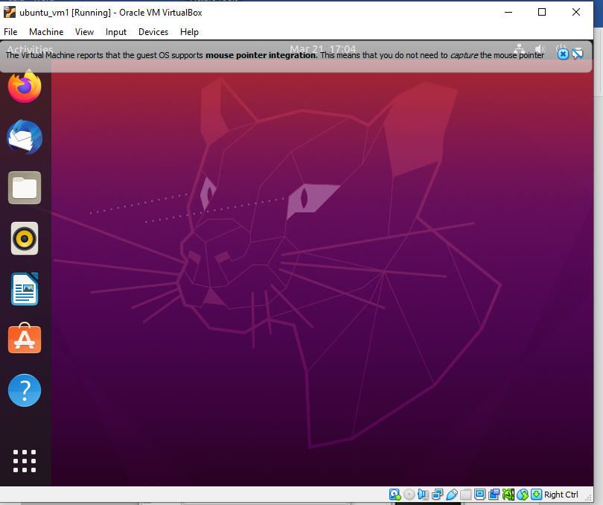

**Output Screenshot**